Proxy

🌐 What is a Proxy?
# Source: Chatgpt (GPT‑5 Mini) at [1/14/2026]
A proxy (or proxy server) is an intermediary between your device and the internet. When you use a proxy, your requests (like visiting a website) go through the proxy server first, and then it sends the response back to you.
📌 In simple terms: a proxy is a middleman for your internet traffic.

🧠 How It Works
# Source: Chatgpt (GPT‑5 Mini) at [1/14/2026]
Without a proxy:
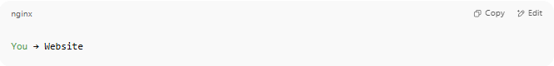
You → Website

With a proxy:

You → Proxy Server → Website → Proxy Server → You

The website sees the proxy as the visitor — not you.

🔍 Why Use a Proxy?
# Source: Chatgpt (GPT‑5 Mini) at [1/14/2026]
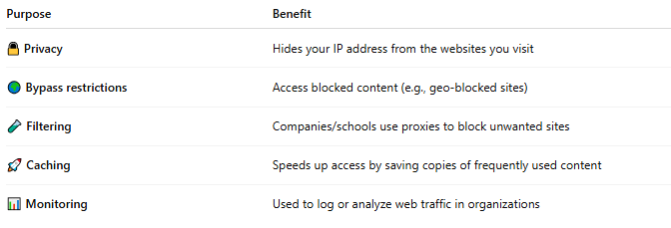
Purpose | Benefit
🔒 Privacy | Hides your IP address from the websites you visit
🌍 Bypass restrictions | Access blocked content (e.g., geo-blocked sites)
🧪 Filtering | Companies/schools use proxies to block unwanted sites
🚀 Caching | Speeds up access by saving copies of frequently used content
📊 Monitoring | Used to log or analyze web traffic in organizations

🧩 Common Types of Proxies
# Source: Chatgpt (GPT‑5 Mini) at [1/14/2026]
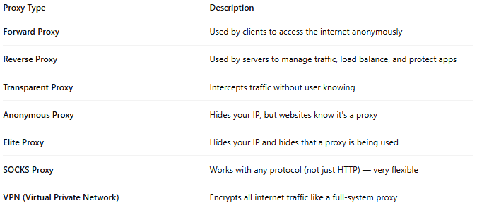
Proxy Type | Description
Forward Proxy | Used by clients to access the internet anonymously
Reverse Proxy | Used by servers to manage traffic, load balance, and protect apps
Transparent Proxy | Intercepts traffic without user knowing
Anonymous Proxy | Hides your IP, but websites know it's a proxy
Elite Proxy | Hides your IP and hides that a proxy is being used
SOCKS Proxy | Works with any protocol (not just HTTP) — very flexible
VPN (Virtual Private Network) | Encrypts all internet traffic like a full-system proxy

✅ Summary
# Source: Chatgpt (GPT‑5 Mini) at [1/14/2026]
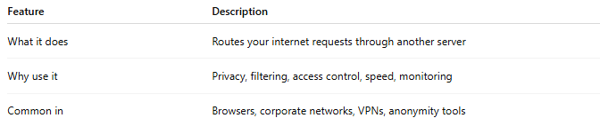
Feature | Description
What it does | Routes your internet requests through another server
Why use it | Privacy, filtering, access control, speed, monitoring
Common in | Browsers, corporate networks, VPNs, anonymity tools

